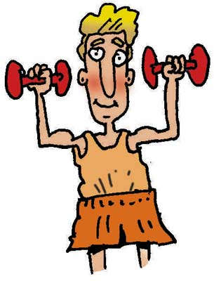
Body Parts

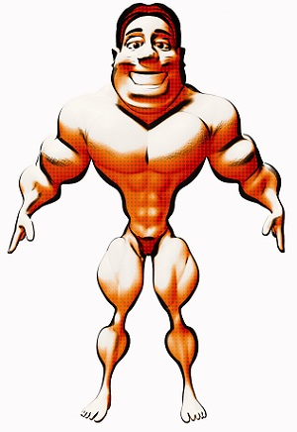
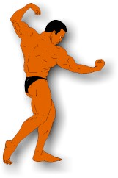
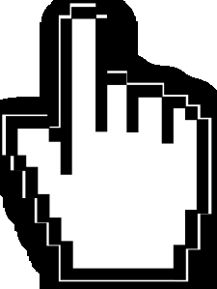
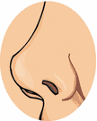

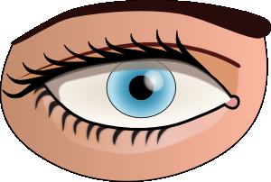

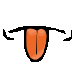
hand
waist
hip
belly
thigh
leg
finger
knee
back
bottom
heel
sole
biceps
toes
ear
shoulder
ankle
shin
calf
index finger
thumb
middle finger
pinkie
lips
eyebrow
eyelash
pupil
tongue
elbow
eyelid
ring finger
mouth
nose
foot, feet
chest
forehead
tooth, teeth
nostril
wrist
eye
face
head
neck
temple
arm
elbow
Body Parts

waist
belly
finger
knee
bottom
sole
toes
ear
shoulder
calf
thumb
middle finger
pinkie
eyelash
pupil
eyelid

nostril
wrist
face
temple
elbow
mouth
foot, feet
chest
Body Parts

hand
hip
thigh
leg
back
heel
biceps
ankle
shin
index finger
lips
eyebrow
tongue

ring finger
eye
arm
forehead
head
nose
tooth, teeth
neck

